Data Structures and Algorithms Laboratory Exam 2a
Weighting – 15%
14/12/09

Answer Question 1 and Question 3 and any 1 other question

Questions 1 and 3 are worth 40 marks, Questions 2 and 4 are worth 20 marks each

Time allowed: 1 hour

Question 1

- Write out the inorder, preorder and post order output for the tree below:

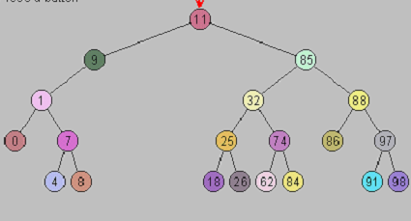
9
18

(10 marks)

- Write a small driver program that demonstrates the ADT Binary Tree. Exercise all of the methods to prove that the data is processed correctly. Perform preorder, inorder and postorder traversals using a BinaryTree iterator.

(15 marks)
- Give Java code for the following BinaryTree method:

public void attachRightSubtree(BinaryTree rightTree) throws TreeException

You may assume the existence of all the class members in the class BinaryTree and BinaryTreeBasis.
(15 marks)

Question 2

(a) Draw the following graph

G= ({1, 2, 3, 4, 5, 6}, {{1, 2}, {1, 4}, {2, 5}, {2, 6}, {3, 4}, {3, 5}, {3, 6}, {4, 5}, {4, 6}, {5, 6}})
(10 marks)
(b) For the graph in part (a) list

- The Adjacency Matrix
- The Adjacency List

(10 marks)

Question 3

(a) For the following graphs, give the order that the nodes will be visited when doing:

- A depth-first traversal starting at the node labelled with a 1.
- A breadth-first traversal starting at the node labelled with a 1.

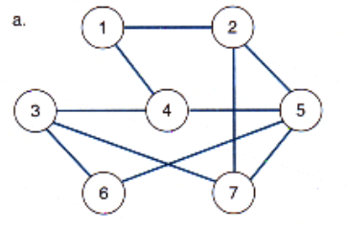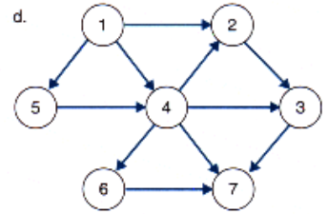

(14 marks)

(b) Find the MST (minimum spanning tree) for the graph illustrated below using:

- Dijkstra-Prim Algorithm (show all steps).
- Kruskal Algorithm (show all steps).

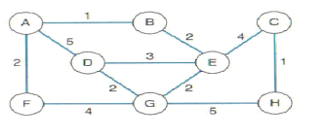
(26 marks)

Question 4

(a) State the measure of complexity for each of the algorithms (a)-(f) below where n is the input size and (a)-(f) represent the number of operations performed by the algorithm.

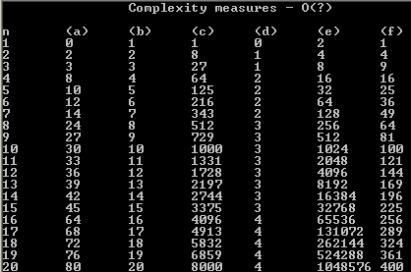

(10 marks)

(b) In your opinion, which of these is worst and which is best. Give reasons for your answer. What does big O notation tell us about an algorithm?
(10 marks)

